Summary of activities of the UOKiK in 2024.
- In 2024, the President of UOKiK issued more than 750 decisions in the field of competition and consumer protection.
- He imposed more than PLN 937 million in fines, of which more than PLN 650 million for practices restricting competition and more than PLN 260 million for violations of collective consumer interests and for declaring clauses to be prohibited.
- He also prepared guidelines relevant to consumers and businesses.
[Warsaw, 26 February 2025] – Last year was a time of many consumer and competition protection activities in Poland. The sheer number of more than 750 decisions testifies to what an intensive year it has been. However, it is also worth remembering our other activities, which are not covered by statistics. In the area of competition protection, I would like to draw attention to the guide on collusion in the labour market. The court ruling was also very important, confirming the validity of our jurisprudence on cases of unfair exploitation of contractual advantage by retail chains. In the consumer protection division, it was important to issue a set of recommendations for payment service providers - concludes President of UOKiK Tomasz Chróstny.
COMPETITION PROTECTION
Competition-restricting practices
In 2024, the President of UOKiK initiated 26 procedures relating to practices restricting competition, 11 of which were anti-monopoly procedures (of which seven related to collusive bidding) and 15 were investigations. The President of the Office issued 13 decisions in this regard. 11 concerned prohibited agreements and two concerned abuses of dominance. 5 of these adjudications concerned the restriction of competition when entrepreneurs bid for public contracts. In addition, on 76 occasions entrepreneurs received calls to voluntarily change their practices, so-called soft calls.
The total amount of fines imposed on entrepreneurs for competition-restricting practices was more than PLN 650 million and on managers more than PLN 4 million. The highest monetary sanctions imposed in a single decision on companies and managers amounted to almost PLN 408 million. They concerned price collusion and market sharing between KIA Poland and its car dealers. Due to the terms of the price fixing agreement, for a period of at least eight years, from 2013 to 2021, buyers of KIA cars could only buy a vehicle from a pre-determined dealer, with no possibility of receiving a cheaper offer from another dealer. Fines were imposed on 12 entrepreneurs and 5 individuals.
This was not the only decision of the President of UOKiK concerning the automotive market. Yet another decision concerned collusion between the importer of trucks Iveco Poland and distributors of these vehicles. The agreement was that the entrepreneurs agreed on areas where the local distributor had priority for customer service. The division of the market was supported by price arrangements. Financial penalties imposed on 11 entrepreneurs and 10 managers amounted to more than PLN 241 million.
The President of UOKiK also monitors the state of competition in digital markets. He launched a preliminary investigation after the changes introduced in Facebook by Meta Platforms Ireland. Contents of Polish publishers on the platform are displayed as a single link and not as before, as a visual preview of the material in question. The change could result in lower interest in journalistic content and reduce the number of views of the articles. In its preliminary investigation, UOKiK is looking into the practices of social media owners, in particular whether Meta may have abused its market position.
Also noteworthy is the publication of a guide to collusion in the labour market. This was particularly important given the lack of common knowledge that certain employer practices could be considered restrictive on competition. The President of UOKiK identified these actions with specific examples, such as co-agreeing on wages for employees or failing to give raises, or arrangements not to compete for an employee. Labour market preliminary investigations were also launched in 2024. The practices of the owners of the Biedronka and Dino chains, who, together with the transport companies, may have agreed not to compete for their employee drivers, are under scrutiny.
Bargaining power advantage in competition for contracts
In the area of contractual predominance, a court judgment is particularly noteworthy, confirming the President of UOKiK’s line of rulings regarding contacts between large retail chains and suppliers of agri-food products. This is about the ruling of the Competition and Consumer Protection Court, which confirmed the 2020 decision. The Court agreed with the President of UOKiK’s findings that Jeronimo Martins Polska was not entitled to obtain previously unagreed discounts from grocery suppliers. The Court also set a fine of more than half a billion zloty (PLN 506 million).
In 2024, the President of UOKiK also initiated three preliminary investigations and issued one decision on practices unfairly exploiting contractual predominance. He also made 31 soft calls to entrepreneurs. 7 of them concerned calls for large fruit processors to change their business practices. 5 of them voluntarily complied, reducing payment terms for perishable fruit and allowing verification of quality tests.
In 2024, the President of the Office also engaged in a dialogue with sugar producers in order to develop new standards for the supply of seed to sugar beet growers and to allow them greater access to the seed offered on the market. The actions taken resulted in modifications to the provisions of the All-Poland Industry Agreement, to which all sugar producers operating in Poland are signatories.
Concentration control
In 2024, the President of UOKiK issued 312 merger approvals of which 3 were conditional decisions. They concerned the following markets: cables and wires, cement and fuels. There were also 353 new procedures opened in which it was verified that the planned transactions would not adversely affect competition.
An example of a consent for concentration is the decision on the acquisition of control of Greenwich by Lisner Holding and the acquisition of part of the Koral property from Tczew. Entrepreneurs are involved in, among other things, the production of prepared meals, particularly fish products. As part of the procedure, the President of the Office conducted a survey among the competitors and counterparties of the participants in the concentration. On the basis of its findings, he concluded that the transaction would not lead to a significant restriction of competition.
The President of the Office also issued 3 investment control decisions.
Payment backlogs
In 2024, the President of UOKiK focused on soft measures and calls to entrepreneurs whose payment discipline was questionable. In 2024, 79 such calls were issued. Independently, procedures were conducted in which 2.8 million invoices were analysed. In 2024, the President of UOKiK initiated 31 prosecutions.
In order to combat payment backlogs, UOKiK monitors the market using various sources of information - both publicly available and its own analyses. Notifications from entities that suspect they have fallen victim to payment backlogs are also valuable. In 2024, the Office dealt with 28 notices of suspected excessive delay in the payment of financial obligations.
State aid
State aid results in the state’s interference with free market mechanisms. Hence, its use is restricted. UOKiK performs a preliminary assessment of individual support and aid schemes, evaluating their compliance with EU legislation, and monitors state aid, i.e. assistance granted to entrepreneurs in Poland.
In 2024, the Office issued opinions on 26 aid scheme and individual aid projects. UOKiK received 778 requests for interpretation and 175 draft government documents for analysis in terms of the possible presence of state aid. Moreover, the Office received 3,109 projects concerning de minimis schemes which it evaluated in terms of transparency of aid granting rules.
The President of UOKiK notified the European Commission in 2024 of 23 projects providing for state aid, including 12 aid schemes and 11 for individual aid. The European Commission accepted 18 aid projects.
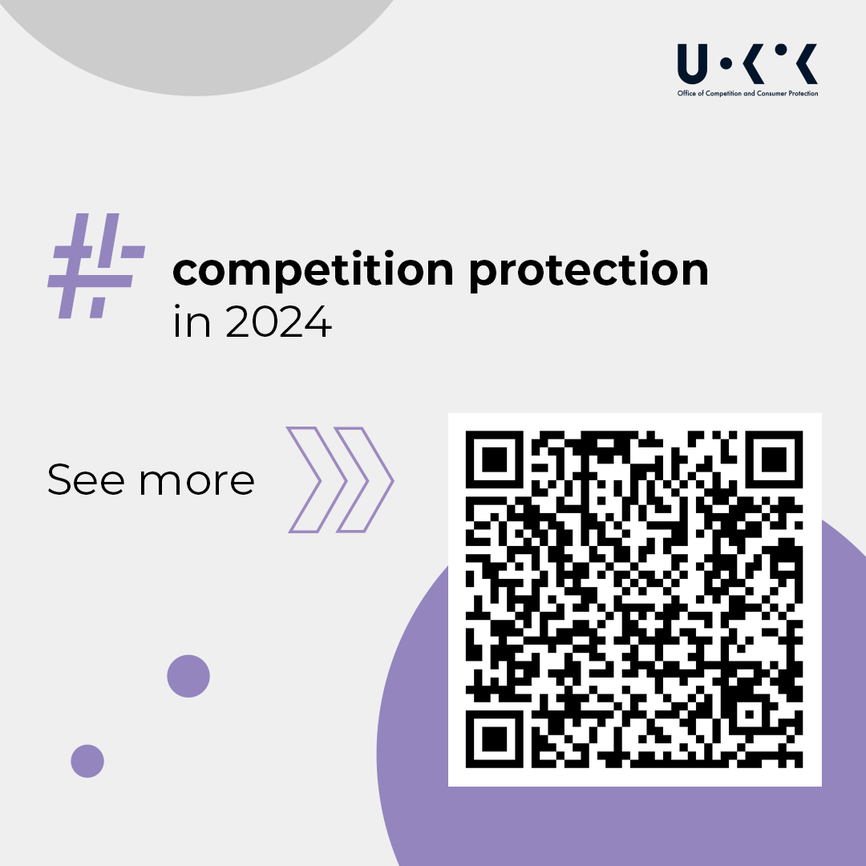
CONSUMER PROTECTION
Protection of collective consumer interests and abusive contractual clauses
In 2024, the President of UOKiK initiated 41 procedures related to practices that violate collective consumer interests and concerning declaring the provisions of a model contract to be unlawful, as well as 128 preliminary investigations. He issued 70 decisions in which he imposed almost PLN 263 million in monetary sanctions on businesses and over PLN 2.5 million in fines on managers. The President of the Office also issued 267 soft calls to entrepreneurs in the field of consumer protection.
The highest penalty concerned PayPal Europe’s use of prohibited clauses in contracts with consumers. “The PayPal User Agreement” contained, among other things, an open-ended set of dozens of actions that the company considered prohibited along with a catalogue of, very severe and difficult to justify sanctions. The clauses were structured in such a way that they allowed the company’s decisions to be arbitrary. For example, it could “at any time” and “at its discretion” block the user’s money “in the amount as high and for a period as long as necessary”. The violation could even be unrelated to the use of a PayPal account. In his decision the President of the Office imposed a fine of more than PLN 106 million.
Due to the serious violations, the President of the Office imposed heavy fines on companies in the telecommunications industry. This includes more than PLN 68 million penalties on Vectra for clauses under which it increased charges to its customers. He also initiated procedures against Vectra, as well as Multimedia Polska, concerning the way in which prices are presented and the practice of increasing charges by the value of the discount, to consumers who do not pay their bills on time or are in arrears.
In 2024, there were also procedures pending against P4, CANAL+ and T-Mobile for penalising consumers with the loss of one of their discounts for non-payment of an invoice on time. In them, the President of UOKiK also checks how operators present the prices of telecommunications services.
The owner of the Amazon platform was ordered to pay a fine of almost PLN 32 million for violating the collective interests of consumers. The company was fined for misleading consumers as to the time of conclusion of the sales contract, availability of products, delivery times and customer rights regarding the “Delivery Guarantee” service.
Janusz Palikot and Polskie Destylarnie, which he manages, were also fined for violating the collective interests of consumers. For misrepresenting the company’s market position, failing to communicate risks, non-existent loan crowdfunding and a fictitious competition in the “Skarbiec Palikota” loan campaign, the President of UOKiK imposed penalties totalling nearly PLN 1.2 million.
In 2024, UOKiK has been investigating the behaviour of banks in the event of unauthorised transactions, but also working intensively to improve the security of payment transactions. A working group set up by the President of the Office, with the participation of, among others, the Office of the Polish Financial Supervision Authority and experts from the banking sector, worked on solutions to reduce the risk of fraudulent transactions. As a result, a set of recommendations for payment service suppliers has been developed. The document prepared at UOKiK includes a list of risk factors and a set of recommendations to reduce the possibility of fraudulent transactions over the internet.
Trade Inspection
The President of UOKiK strives to ensure product safety in Poland, among other things, by means of the Trade Inspection Authority. The Office plans, coordinates, monitors and analyses the results of inspections carried out by the provincial inspectorates of the Trade Inspection Authority. In 2024, the Trade Inspection Authority carried out a total of more than 14,500 inspections in the field of general product safety, product conformity assessment and other inspections concerning non-food products and services (including information obligations towards consumers).
In 2024, UOKiK’s laboratories tested a total of 1,935 samples in connection with the Trade Inspection Authority’s inspections, in which more than 19,500 parameters were tested. Checks last year included heat pumps, cookers and fireplaces, as well as seasonally popular products - scooters, bicycles, bicycle helmets or pyrotechnic products - as particularly dangerous. We paid particular attention to products intended for the youngest group of consumers, including scooters, baby strollers and toys. In addition, the checks included equipment commonly used in the household, such as light bulbs and light fittings, ladders, lawnmowers and work gloves.
Reports related to the content of hazardous chemicals in products that each of us comes into contact with on a daily basis were of greatest interest to consumers. The Trade Inspection Authority checked whether “there is chemistry between us” by inspecting 165 batches of bedding, clothing, footwear, haberdashery products and the content of hazardous substances in around 500 children's articles - toys, prams, bicycles, scooters.
UOKiK is also responsible for the management of the fuel quality monitoring and control system: in 2024, the Trade Inspection Authority carried out a total of 1,886 checks of petrol, diesel, LPG and 491 checks of the quality of solid fuels.
Product safety and market surveillance
In addition to the results of Trade Inspection Authority inspections, UOKiK analyses signals from consumers and notifications from the supervisory authorities of other EU Member States within the framework of the EU RAPEX system. As a result, the President of UOKiK initiated 107 general product safety cases, including 64 investigations and 43 administrative procedures. Furthermore, he initiated 259 cases on the conformity of products with EU requirements, including 72 investigations and 187 administrative procedures. UOKiK referred 170 notifications that concerned 1.7 million product items to the Safety Gate/RAPEX system. Most notifications concerned toys.
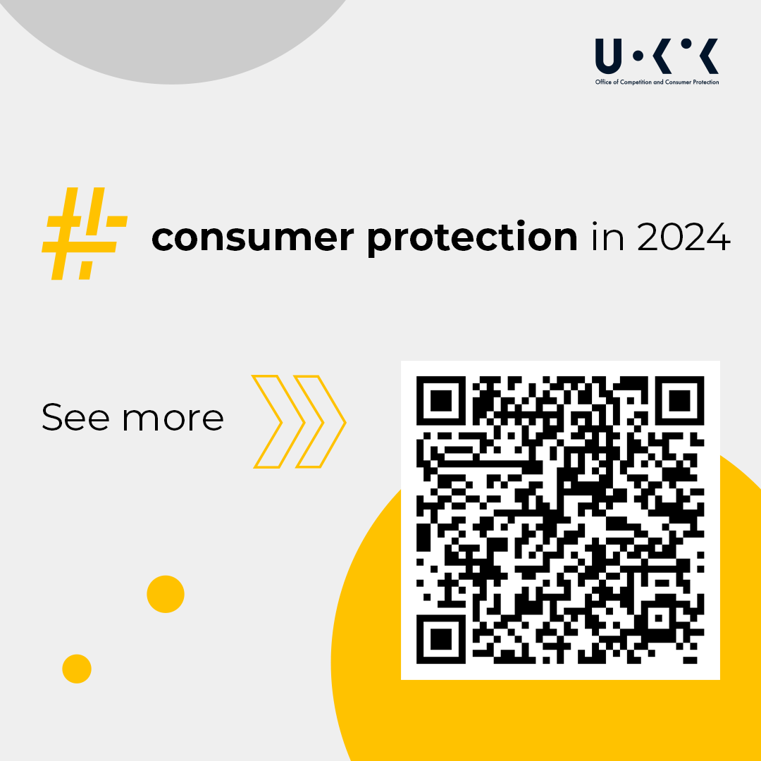
Legislation
Work on the draft Consumer Credit Act began last year. The regulation will impose new information obligations on creditors prior to the conclusion of a credit agreement, including the presentation of general credit information. It will also introduce advertising and marketing requirements for consumer credits, including a catalogue of information that must be included in credit advertising.
In December, legislation came into force that expands the circle of entities responsible for product safety to include online shopping platforms. E-commerce websites are obliged to monitor offers and remove those that do not meet safety requirements.
International cooperation
In November, the President of UOKiK was elected as a member of the OECD Competition Committee for 2025. The Committee brings together competition experts from all OECD member and partner countries.
Moreover, UOKiK has been actively involved in international events for many years. From 1 July 2023 to 30 June 2024, UOKiK exercised the presidency of the International Consumer Protection and Enforcement Network (ICPEN), where it gave direction to the network’s work and inspired global action to protect consumers. The Office has organised two conferences for ICPEN network members - the first in Warsaw (4-6 October 2023) and another in Gdańsk (6-10 May 2024) with a High Level Meeting and a Good Practice Workshop.
The Office has also implemented projects under development cooperation initiatives carried out for EU candidate or developing countries. The programmes were implemented with funding from the Ministry of Foreign Affairs and the European Union. Institutions from Ukraine, Moldova, Albania, Georgia and Kenya were the beneficiaries of UOKiK’s activities.
Education
2024 is another year full of UOKiK’s information and education activities implemented through websites and social media, social campaigns, publications, interactive tools, competitions, funding of projects carried out by consumer organisations and cooperation with the media and institutions. In its four social media channels (X, Instagram, Youtube, Facebook) the Office had 62 thousand followers, and the posts posted had around one million impressions.
2024 saw 165 press releases and more than 80,000 publications about UOKiK in the media, more than 12 million page views of UOKiK’s services - the new uokik.gov.pl website, thematic services, a fuel map and online calculators, including mortgage interest rates and early repayment refunds.
The President of UOKiK conducted two social campaigns “Check if you can afford it!” with a viral spot and “Investing? Give yourself time. Check, read, ask!”, supported by 400 partners. The Office also awarded PLN 800,000 in grants for 2 educational projects for young consumers between 2024 and 2025 carried out by NGOs selected in the competition.
In addition, the President of UOKiK conducted two initiatives for students: competition for the best master’s thesis and workshops for students – Summer Camp UOKiK ’24.

